Student: Alan Danque

Professor: Anthony Armstrong

Week 6 Exercise: 6.2 - 3 histograms, 3 box plots, 3 bullet charts, and 3 additional charts of your choice

Git Repo Location:

<https://github.com/adanque/DSC640>

All Python, R and Tableau twb scripts and dataset & generated plots are located on this Repo:

<https://github.com/adanque/DSC640/tree/master/Week6>

3 histograms

Python

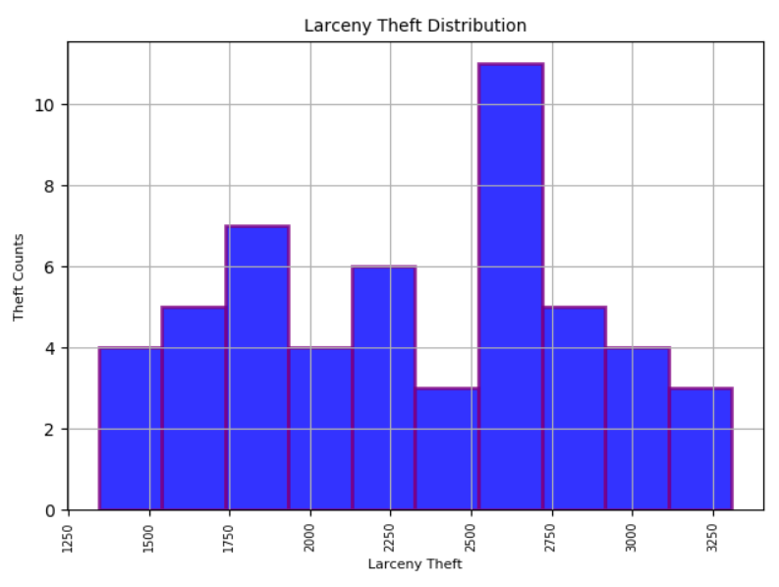

R

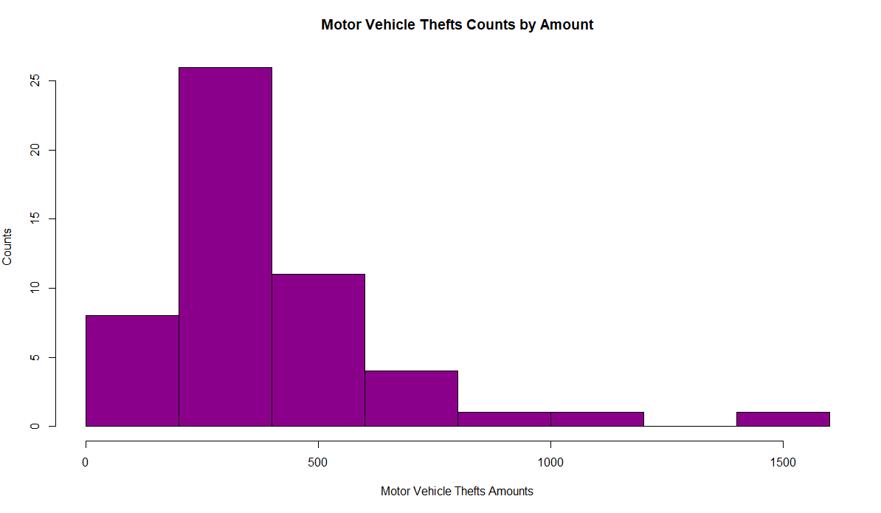

Tableau

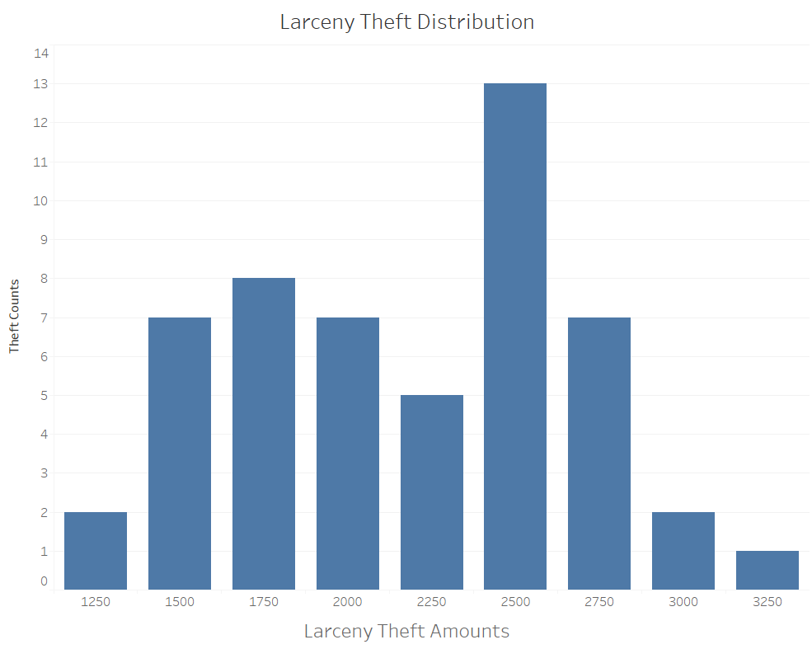

3 box plots

Python

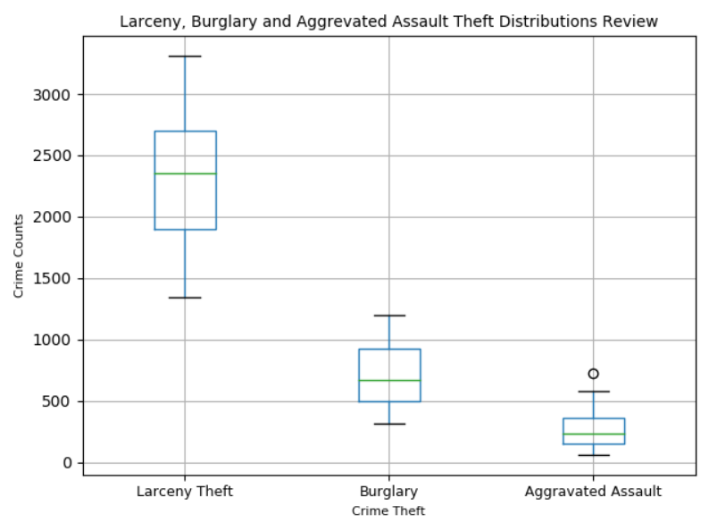

R

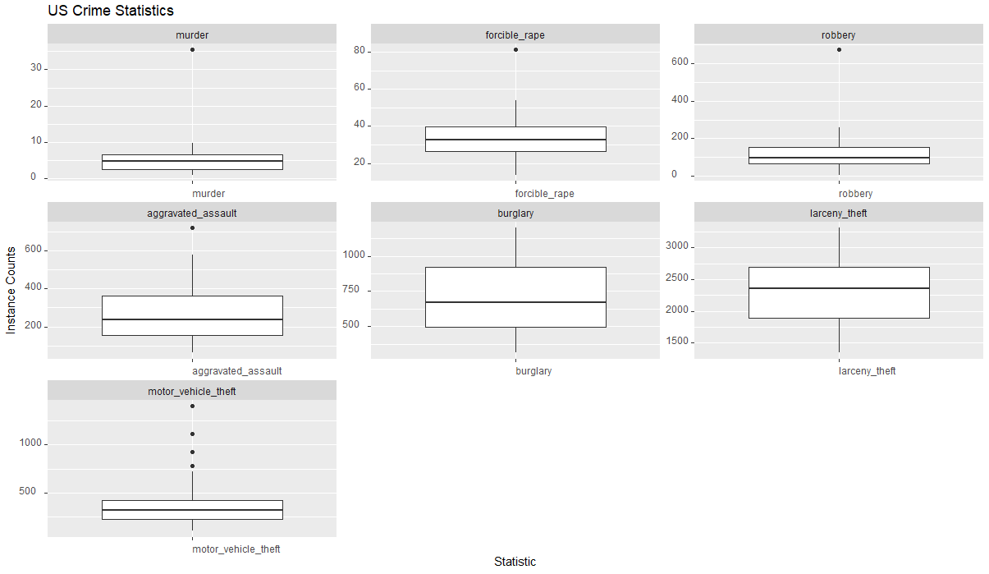

Tableau

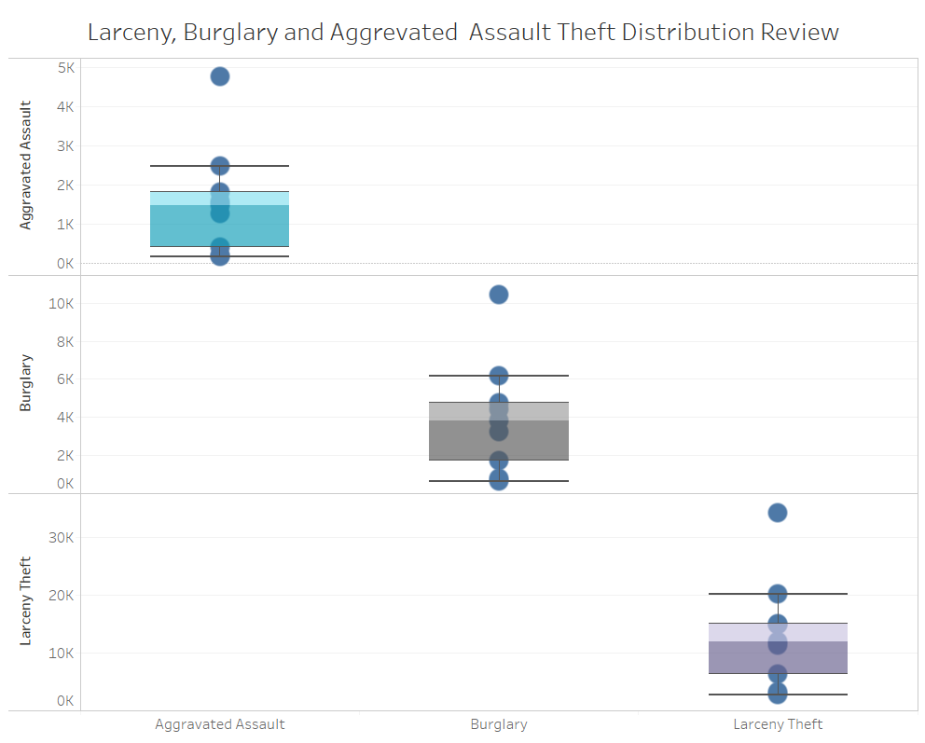

3 bullet charts

Python

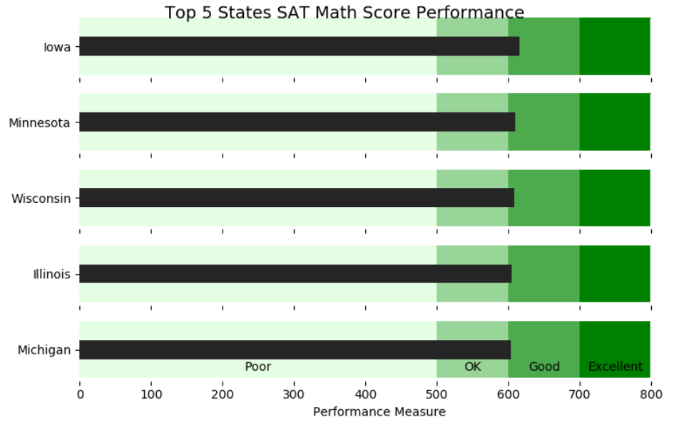

R

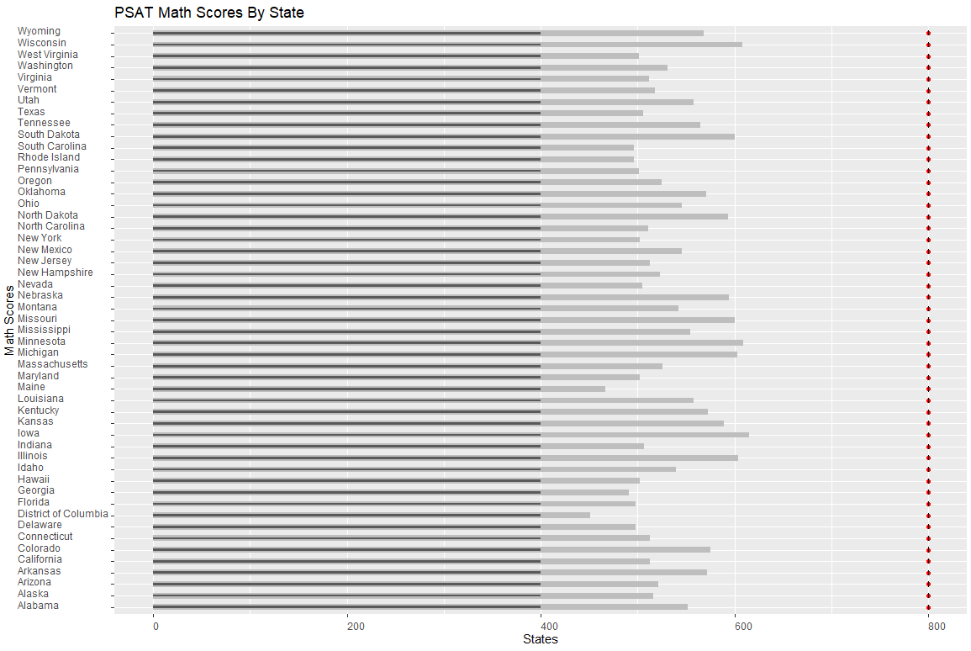

Tableau

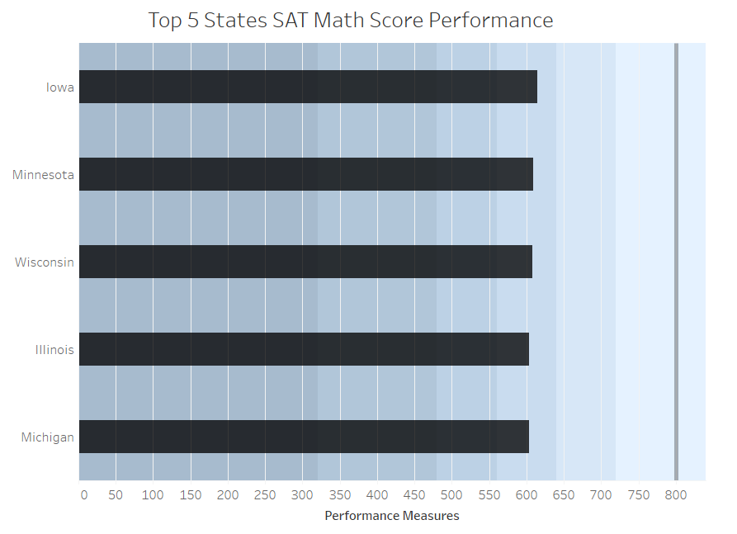

3 additional charts of your choice

Python

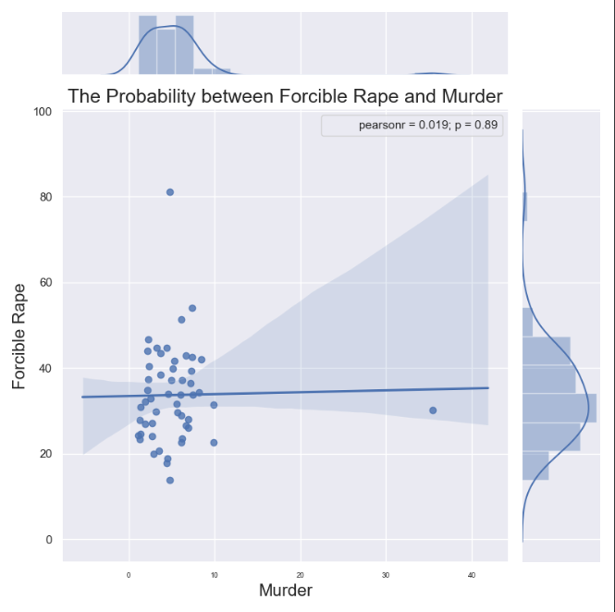

R

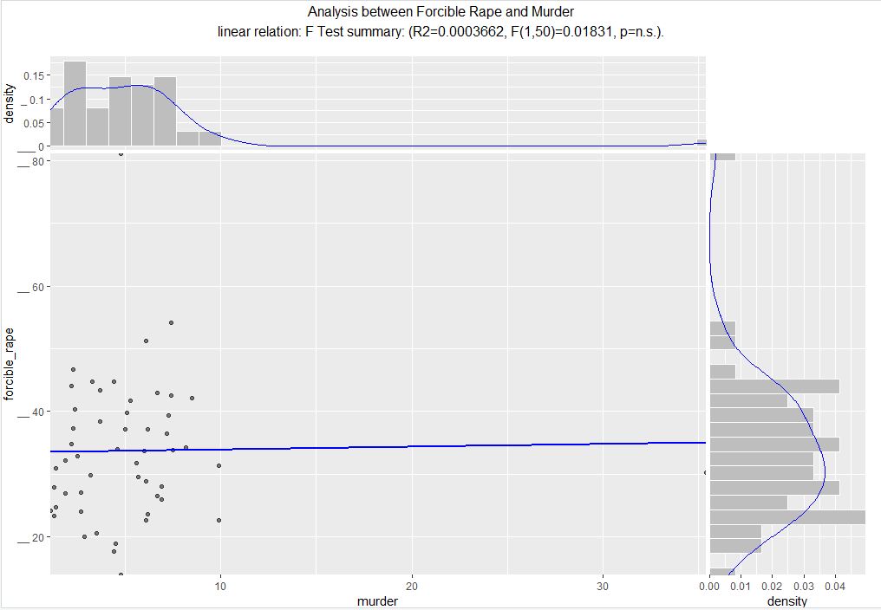

Tableau

